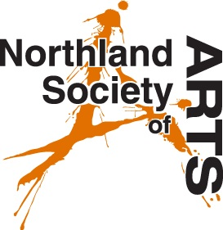
Calendar Competition
Terms & Conditions
These terms and conditions apply to artists who wish to submit an entry in the Reyburn House 2021 Calendar Competition. These terms and conditions must be read, accepted and signed before any artwork can be exhibited.

The NSA Council decides:
1. The dates and length of time of the exhibition.
2. The exhibition fees.
3. Whether an artwork is suitable for display.
4. What artwork is chosen for publicity purposes.
5. How the exhibition is presented

The Artist must ensure:
1. They are a current NSA Member.
2. The artwork is their own original work, not previously entered into a competition.
3. The artwork is ready for display to a professional standard.
4. The artwork is clearly labelled, with their name, the title, medium and retail price of the artwork.
5. Fees are fully paid prior to exhibiting.
6. The artwork is available for promotional purpose and/or publication in the calendar.

The Artist is aware:
1. The Society accepts no responsibility for loss or damage of any exhibit, during transit or while the work is in Reyburn House Gallery.
2. Insurance is the responsibility of the exhibitor/artist.
3. Artwork that is sold attracts a 25% commission plus GST on that commission.
4. Unsold artwork must be collected within 1 week of the exhibition closing. Uncollected artwork will attract a storage fee or be disposed of at the NSA's discretion

I hereby agree to the terms and conditions listed above and confirm my artwork to be entered in the Calendar Competition and exhibited at Reyburn House Art Gallery.

Signature:________________________________

